**Program 15: Demonstrate dynamic polymorphism.**

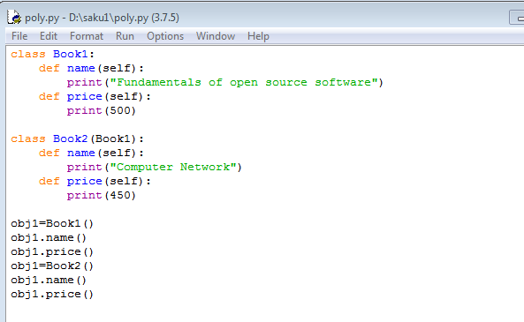

**Output:**

